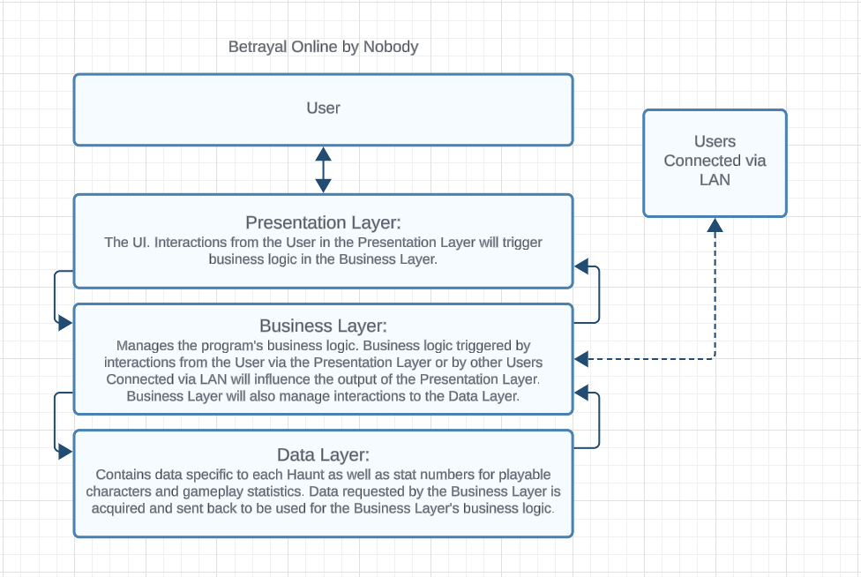

Architectural Pattern for Betrayal Online   
By Nobody

Team 3: Caleb Corlett, Ryan Nodarse, Patrick Storer, Ethan Wyman

## Description:

The Architectural Pattern we are using for Betrayal Online is a Layered Architecture. It is made up of a User interacting with a Presentation Layer, which will trigger business logic in the Business Layer which can, in response, modify the output from the Presentation Layer. The Business Layer can also receive information from other Users connected to the game via LAN to influence the Presentation Layer’s output to the original User. And, if required, the Business Layer can also place requests to store and retrieve data inside the Data Layer for business logic tasks.

## Why Layered Architecture for Betrayal Online (Justification):

The functionality of our program in regards to User input as well as interactions with the database would be well represented by the separated layers of a Layered Architectural pattern. The User does not need to interact directly with the data stored in the Data Layer, so the Business Layer would be a helpful middle-man to handle the business logic and manipulate the Presentation Layer so that the User doesn’t have to interact with anything besides what they are meant to. Doing so in a unidirectional way often associated with the Layered Architectural pattern.